INTERTWINED REALITIES  
 **- Rushil Bhutani and Ishita Agghi, BVCOE**

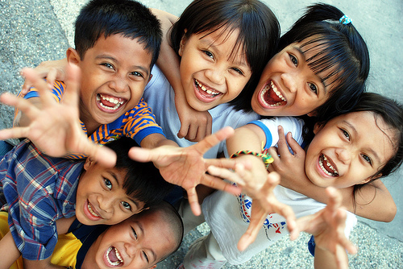

Oliver twist and Annie would have been successful in etching their image of the orphanage in my head, if it wasn’t for that one day when we had to visit an orphanage. Our imagination of the orphanage died on the word dreary. For us, like many others, administrators of orphanages were cruel monsters, food and clothing was scarce, and the children savage. The facts somehow seemed to support my image of the orphanages. The juvenile home where underage criminals are sent is actually an orphanage run by the state. We come face to face with scams every day; the newspaper sure gives us a dose of it. There are many orphanages set up as a front to lure foreigners to pay school fees for children who are in turn employed for back-breaking work. There was news in the papers recently, stating that some owners deliberately kept the conditions of orphans miserable to attract more donations. To show you the rosy side, it’s not the same everywhere. We were greeted by the orphanage manager at the gate who ushered us in. The house had an air of vitality and by the look on the manager’s face you could tell how proud she was of her work. She showed us around the colorful dining house, the study room with a wall chest of books, the bedroom with bunker beds and the playroom filled with toys. What caught our eye was the infant room- soft pink bedding with a blanket of another shade of pink drawn over the little ones. Two housemaids were ready on their feet to do the needful always. When we were about to exit, the warden invited us for luncheon and one of the kids going by told us that ‘Chicken Biryani’ was on the menu. It was the first time we had caught a glimpse of developed India where innocence is catered to, not deceived. On our way out there was a board showing the orphanage’s successes in numbers. The number of kids that were admitted from all parts of the country was huge. While exiting, we had a feeling which was difficult to name but it was of the best kind. It may sound cheesy but the exit from the gate may have ended this journey of our visit but it started a new one. We never went to the orphanage again but we still cherish those happy memories and it was the best thing that happened to us.

